At first, the Aboriginal people of Sydney were not hostile to the European settlement, but conflict increased as the colony expanded because European ways of using the land are so different to the ways in which Aboriginal people traditionally use the land.
Below is a table of some of the approaches the colonials took and the Aboriginal approach. As you read the table think about how these differences might cause conflict between the colonials and Aboriginal people.
Colonial Approach | Traditional Aboriginal Approach | How these differences might have caused conflict/problems.
The colonials allocated ownership of land to individuals. | Tribal lands are shared among the tribe and no one owns it (it owns them in a sense as they belong to it). | Colonials often got angry with and attacked Aboriginal people who were on ‘their’ land.
Colonials fenced off their land to keep others out and animals in. | No fences- shared use of the land among the tribe (and sometimes with other tribes). | Fences stopped Aboriginal people accessing their traditional lands and food sources.
The British government encouraged the expansion of farming to make the colony more self –supporting taking up more and more land. | Each tribal group had its own designated area and visitors needed permission to enter the land of another tribe. | As the colonials took more and more land it pushed Aboriginal people out of their traditional land into land that could not support them well or into the territory of other tribes.
Anything produced by a European farmer belonged only to that farmer to use or sell as they wished and others were not allowed to just help themself to it. | Food grown or caught on tribal land was available for all in the tribe and shared. | Colonial farmers would have regarded Aboriginal people taking their animals or crops as stealing, but Aboriginal people were just following their ways- if it was grown on their land then they had the right to eat it.
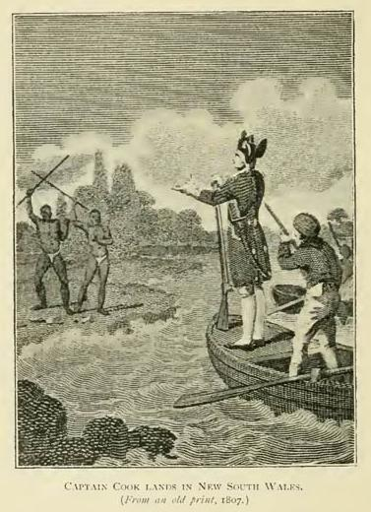
Answer the following in your workbook.
- Using your knowledge of tradition Aboriginal societies and European farming methods, explain why the British occupation was likely to cause conflict.
- Look at the picture to the left is from 1807- it shows early colony contact with Aboriginal people and then answer the following:
- What message do you think the British captain (Governor Phillip?) is trying to express with his gestures in the picture?
- What message do you think the Aboriginal people are trying to convey by holding their spears in the air?
- Pretend you are a Cadigal or Eora person (tribal groups from the Sydney region) in 1788 and write a diary entry to describe how you feel about the British occupation.

