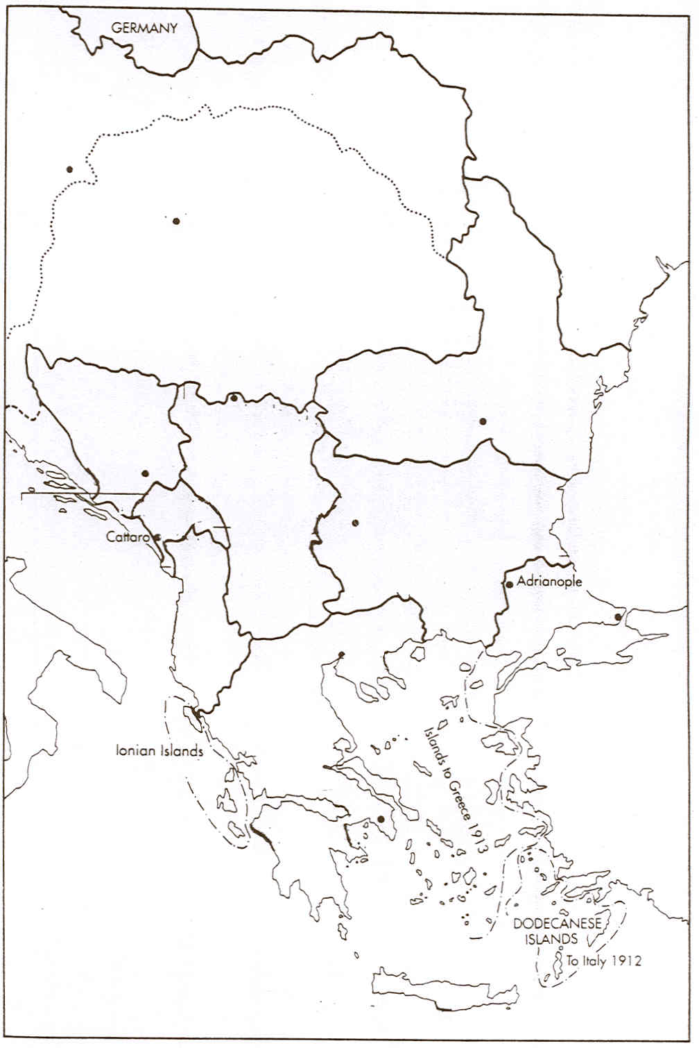
THE BALKANS = PRE 1914

Place these countries on the map and colour each one a different colour – then stick in your books.
AUSTRIA
SERBIA
MONTENEGRO
BULGARIA
ROMANIA
RUSSIA
TURKEY
GREECE
ALBANIA
BOSNIA

