Experiences of Contact between Aboriginal and Non-Aboriginal peoples 1820 to 1900

Key concepts: terra nullius dispossession
The interactions between Aboriginal and non-Aboriginal peoples varied in the early contact years. Aboriginal people often helped and cooperated with settlers and were also often treated well by settlers. But Aboriginal people were also intentionally and unintentionally dispossessed of their lands and treated poorly (even killed!) Aboriginal people were often very cooperative and helped settlers with tracking and many other activities, but as Aboriginal people became threatened by settlers and were cut off from their traditional lands and food supplies, they showed resistance and came into increasing conflict with settlers.

Official British Policy
The official policy of the British Government was to establish friendly relations with Aboriginal peoples and to offer them the protections of British Law. However, the British had no understanding of Aboriginal society and Aboriginal relationships to the land. Nor did the British recognise Aboriginal ownership of the land. In British legal language, Australia was declared terra nullius which means 'land belonging to no one’. The British believed they had the right to take ownership of Australia because it was terra nullius.
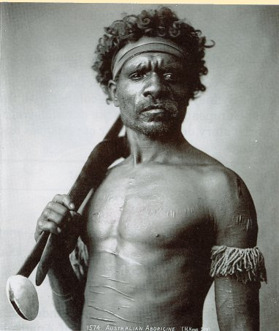
The British wanted Aboriginal people to become Christians and to obey British laws, live and work in European ways and become 'civilised' .
Picture of an Aboriginal man taken in the 1800s

Governor Macquarie's Approach
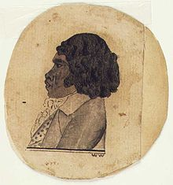
In 1816 Governor Phillip Macquarie set aside areas around Sydney as agricultural reserves for Aboriginal people who wished to become farmers and 6 months of government assistance (including convict labour) was offered to help with this. But in the same year Macquarie also proclaimed that settlers could fire upon Aboriginal people who appeared to threaten their farms. His aims were to end Aboriginal resistance while encouraging them to take up the ways of the British.
Pemulwuy was eventually shot by the colonials in 1802 after years of resistance. The colonials then cut off his head, preserved it in spirits and shipped it off to England to put on display! His people would today like this head to be returned, but it cannot be found to be repatriated.
^ A colonial sketch of Bennelong
Revision Questions:
Use this and the information from History Zone page276 to answer these questions.
1. What was the official British policy toward Aboriginal peoples in colonial times?
2. What does terra nullius mean and what did this legal interpretation allow Britain to do under British Law?
3. How was the situation in regards to taking land in Australia different to what happened in New Zealand with Maori land? (use the terms ‘dispossession’ or ‘dispossed’ and terra nullius in your answer).
4. Who were Arabanoo, Colebee and Bennelong and what happened to them?
5. Who was Pemulwuy and what happened to him?
6. Were the colonials and Aboriginal peoples always in conflict with each other in colonial times? Explain your answer.
7. What were the main causes of conflict between the colonists and Aboriginal peoples?
8. Why did Governor Macquarie both offer help to Aboriginal people to help them start farms AND give permission for settlers to shoot Aboriginal people?

Experiences of Contact Between Aboriginal and Non-Aboriginal peoples 1820 to 1900
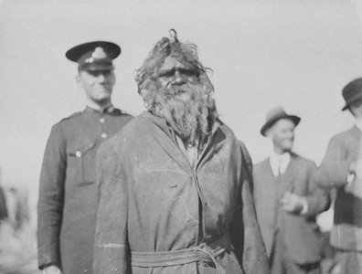
The interactions between Aboriginal and non-Aboriginal peoples varied in the early contact years. Aboriginal people often helped and cooperated with settlers and were also often treated well by settlers. But Aboriginal people were also intentionally and unintentionally dispossessed of their lands and treated poorly (even killed!) Aboriginal people were also often very cooperative and help settlers with tracking and many other activities, but as Aboriginal people became threatened by settlers and were cut off from their traditional lands and food supplies, then they showed resistance and came into increasing conflict with settlers.

Official British Policy
The official policy of the British Government was to establish friendly relations with Aboriginal peoples and to offer them the protections of British Law. However, the British had no understanding of Aboriginal society and Aboriginal relationships to the land. Nor did the British recognise Aboriginal ownership of the land. In British legal language, Australia was declared terra nullius which means 'empty land'. The British believed they had the right to take ownership of Australia because it was terra nullius

The British wanted Aboriginal people to become Christians and to obey British laws, live and work in European ways and become 'civilised' .

Governor Macquarie's Approach
In 1816 Governor Phillip Macquarie set aside areas around Sydney as agricultural reserves for Aboriginal people who wished to become farmers and 6 months of government assistance (including convict labour) was offered to help with this. But in the same year Macquarie also proclaimed that settlers could fire upon Aboriginal people who appeared to threaten their farms. His aims were to end Aboriginal resistance while encouraging them to take up the ways of the British.
Revision Questions:
Paste this sheet into your book, then write the answers in your work book in full sentences that include reference to the question being asked.

1. What was the official British policy toward Aboriginal peoples in colonial times?
2. Why did Governor Macquarie both offer help to Aboriginal people to help them start farms AND give permission for settlers to fire at Aboriginal people?
3. What does terra nullius mean and what did this definition of Australia allow the British to do under British Law?
4. Do you think that the British terra nullius ruling was just and fair? Justify your answer

Colonial Expansion and Frontier Conflicts

By 1810, the plains of Sydney were becoming overcrowded and the colonials sought to expand the colony.

Crossing the Blue Mountains
Blaxland, Lawson and Wentworth were the first three Europeans to find a way across most of the mountains. Later that year, George Evans used the path and explored the land and plains over the mountains. He named the Bathurst Plains and the Fish and Macquarie Rivers.

Further inland exploration and Pastoral Expansion
The programme of inland exploration, continued in the following years with help from Aboriginal guides who showed them the tracks, water sources, bush food and camping sites. Settlers and squatters quickly took over large areas of land for the sheep and cattle farms.

Pastoral expansion
At first, the governor and authorities tried to control the expansion into the new land by issuing land grants. As more free settlers arrived, however, and more convicts were pardoned, people started to settle or squat on land in the Hunter River Valley, the New England Tablelands, the Liverpool Plains, the Bathurst Plains, the Yass Plains and in what is now central and western Victoria. Other pastoralists brought their flocks from Tasmania across Bass Strait to Victoria.

Aboriginal reaction
The rapid inland expansion of the British colony forced many Aboriginal peoples from their land, and into a war with the settlers. The sheep and cattle destroyed native grasses and other vegetation, ruined waterholes, and competed with native animals. The depletion of resources and the competition for land brought the Europeans and inland Aboriginals into sharp conflict.
Governor Macquarie tried to stop the Indigenous Australians from attacking the settlers. He formed new military outposts and created a law that Indigenous peoples were not allowed to carry a firearm within 2 kilometres of a house or town. The massacres continued, with revenge attacks the most common. In the Liverpool Plains area in northern New South Wales, at least 100 Aboriginal people were killed by troopers after they had killed several European shepherds.

Effects of expansion inland
The expansion inland provided much new land for the British colony and provided the resources for the Australian economy to grow rapidly - particularly the wool industry and later the mining industry. The population of the colony started to increase through immigration, as British people saw that money could be made in the new colony. Living conditions had also improved and more land had become available.
The effects on the Indigenous population, however, were disastrous. The Indigenous populations were reduced substantially because of dispossession, wars and disease. In Victoria, for example, many Aboriginal groups were reduced to perhaps a quarter of their pre-1788 population in one generation. Some Aboriginal peoples elected to work for the settlers as it would mean they could remain on their land. In these cases, some pastoralists recognised that the Indigenous peoples needed to stay on the land, but only as long as they adapted to domestic and station work.

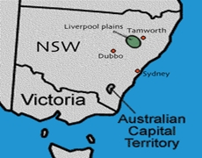
Battles and massacres occurred on the Liverpool Plains, Bathurst Plains, Bells Falls, Myall Creek and other sites .

Colonial Expansion took over many of the traditional lands of
Aboriginal peoples
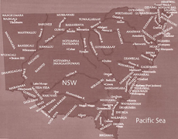

From Mudgee History.comTop of Form

Massacres
There are 20 massacre sites officially recognised around the Bathurst region and many unofficial sites around the Mudgee region. More than 19 white people were killed in the early six year period of t the number of Aboriginal people killed is unknown (estimates vary but average to about 600). The largest massacre of Aboriginal peoples is believed to have happened at Bells Falls near Sofala; here settlers are said to have hearded Aboriginal men women and children onto a cliff face forcing them to jump to their death. Mudgee was counted in the Bathurst region in those early days of settlement.

Bathurst 1822
On William Lee’s farm 10kms north east of Bathurst, A convict shepherd was killed by Wiradjuri on the farm.

March 1824
Kelso on the potato field on the banks of the Macquarie River, where a farmer showed Windradyne, leader of the Wiradjuri people how to cook potatoes. The Wiradjuri people returned next day for more, believing the land, and therefore the potatoes, were theirs. There is no record of how many tribesmen, women and children were killed on that day, but Windradyne escaped.
Arsenic cooked in dampers was also used to kill Wiradjuri people at this time.

May 24, 1824
Warren Gunyah station, Wattle Flat, Mr Lyndall’s farm. Two stock keepers killed and another speared by Wiradjuri men, discovered by William Lee and George Cheshire.
Also on that day at Bathurst, Wiradjuri attacked and burnt a small hut and killed sheep and three shepherds - John Donnelly, Joseph Ross and David Brown - at the Windurndale Riverlet near Bells Falls at Milalah-Murrah, where Samuel Terry built his homestead on a Wiradjuri sacred site where initiation ceremonies were performed, despite protests from the Wiradjuri people. Mr Tindell also lost three servants and had sheep destroyed and huts burned to the ground. A retaliation party set out and William Lawson Jnr recorded they ‘fell in with a horde of their women and dispatched them in return for the men’

MARTIAL LAW IS DECLARED August 14, 1824
WHEREAS the Aboriginal natives of Bathurst, have for many weeks past, carried on a series of indiscriminate attacks on the Stock Stations there; putting some of the keepers to cruel deaths, wounding others and dispersing and plundering the flocks and herds, themselves not escaping sanguinary retaliation:-
AND WHEREAS the ordinary powers of the Civil Magistrates (although most anxiously exertered) have failed to protect the lives of His Majesty’s subjects, and every conciliatory measure has been pursued in vain; and the slaughter of black women and children and unoffending white men, as well as the lawless objects of terror, continue to threaten the before mentioned districts:-

Revision and Further Exploration
1. Complete the following table
Reasons Why Colonials Wished to Expand their territory. | Reasons Why Aboriginal Peoples Resisted Colonial Expansion and Fought Back

Paste this sheet into your book, then write the answers in your work book in full sentences that include reference to the question being asked.

2. Did Aboriginal people always fight with settlers? Explain your answer.

3. Which side lost the most people and suffered the greatest negative effects upon their lifestyle as a result of frontier conflicts and war?

4. Why is it do you think that many more Aboriginal people were killed than settlers? (Hint- compare and contrast tactics, weapons and transport used by each side).

5. Write a sentence explaining the long term effects of colonisation upon Aboriginal people.

6. Using an online dictionary, find the meaning of the word 'dispossession' and write a sentence about this topic that includes this word.

-dispossession

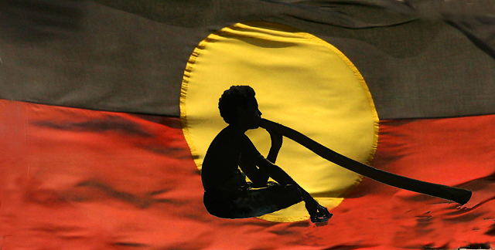

op of Form

