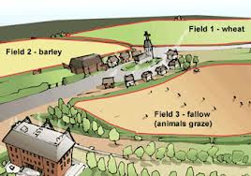 Industrial Revolution Test
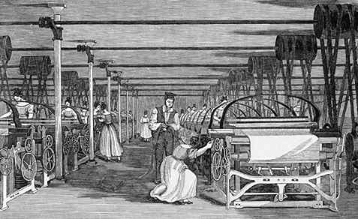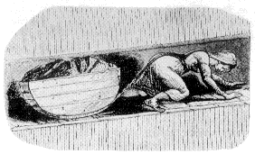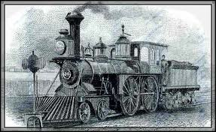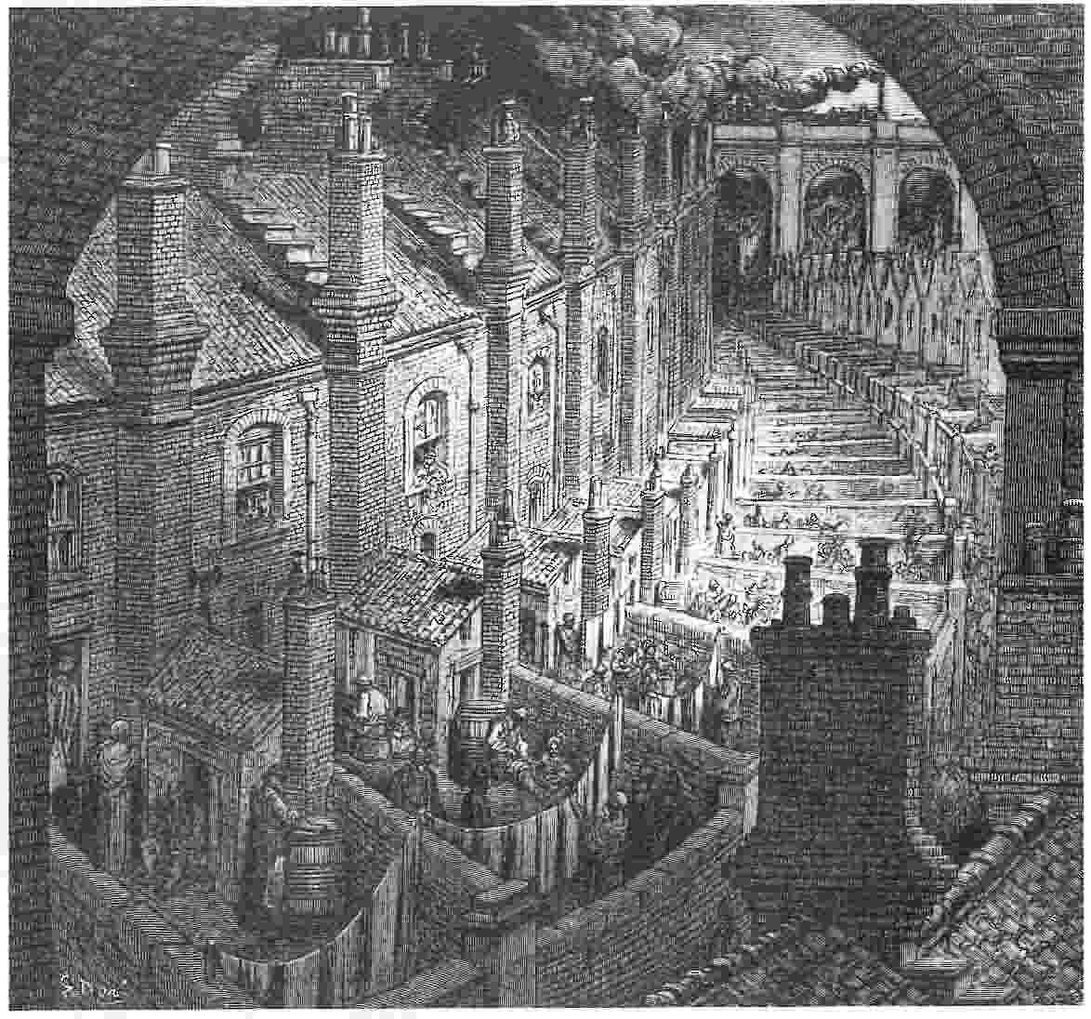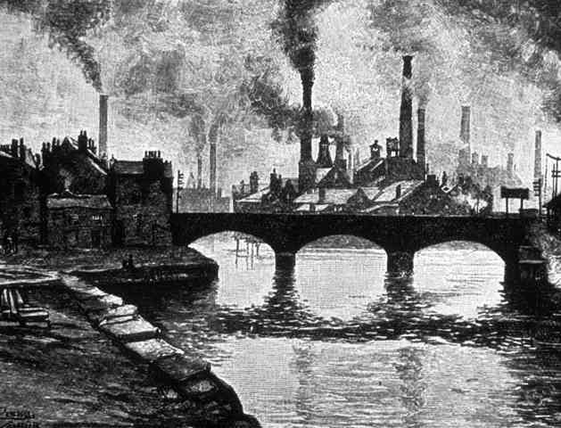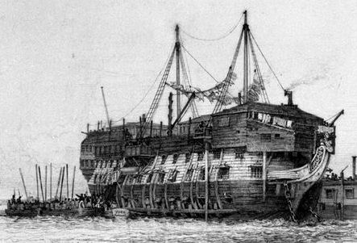
Enclosure
- Discuss two ways the poor were disadvantaged when the Three Field system of farming was replaced by enclosed farms. (2 sentences)
- What were two benefits of enclosure leading up to the Industrial revolution? (2 sentences)
The Industrial Revolution
- Discuss two advantages that one of the innovations of the Industrial Revolution brought to Britain. (2 sentences)
- Write a paragraph as if you were a person living in London at the time of the Industrial revolution, stating three bad things around you that were caused by the Industrial Revolution. (3 sentences)

- Read the following by Dr Michael Ward before a parliamentary committee, 25th March 1819.
List what horrified him about the factories he visited. (2 points)
“I have had frequent opportunities of seeing people coming out from the factories and occasionally attending as patients. Last summer I visited three cotton factories with Dr.Clough of Preston and Mr.Barker of Manchester and we could not remain ten minutes in the factory without gasping for breath. How is it possible for those who are doomed to remain there twelve or fifteen hours to endure it? If we take into account the heated temperature of the air, and the contamination of the air, it is a matter of astonishment to my mind, how the work people can bear the confinement for so great a length of time.”
- Read the following and make a list of the ways Robert Owen improved conditions for the workers at his factory. (4 ways)
Robert Owen bought a share in the New Lanark cotton mills in Scotland in 1800 and managed them for the next 25 years. Owen disagreed with the widespread attitude among factory owners that workers had to be paid low wages and treated poorly to ensure the biggest profits. He stopped employing children under 10 in his factories, provided schooling for the younger children and limited the working hours for children over 10 so they could also attend school. He provided clean, comfortable housing as well as a pleasant working environment for his workers. His business was very successful and he travelled all around Britain promoting his ideas.
- Discuss two reforms that made things better over time for workers living in London at that time. (2 sentences)

