So many people moved to towns during the Industrial Revolution that there were not enough houses. Builders and landlords, who were keen on making large profits, built thousands of new houses but they crammed as many people in as possible and often used the cheapest building materials. Rents were high so whole families had to live in a single room. Sometimes they even took in lodgers to earn extra money. There was little privacy and infectious diseases spread easily.

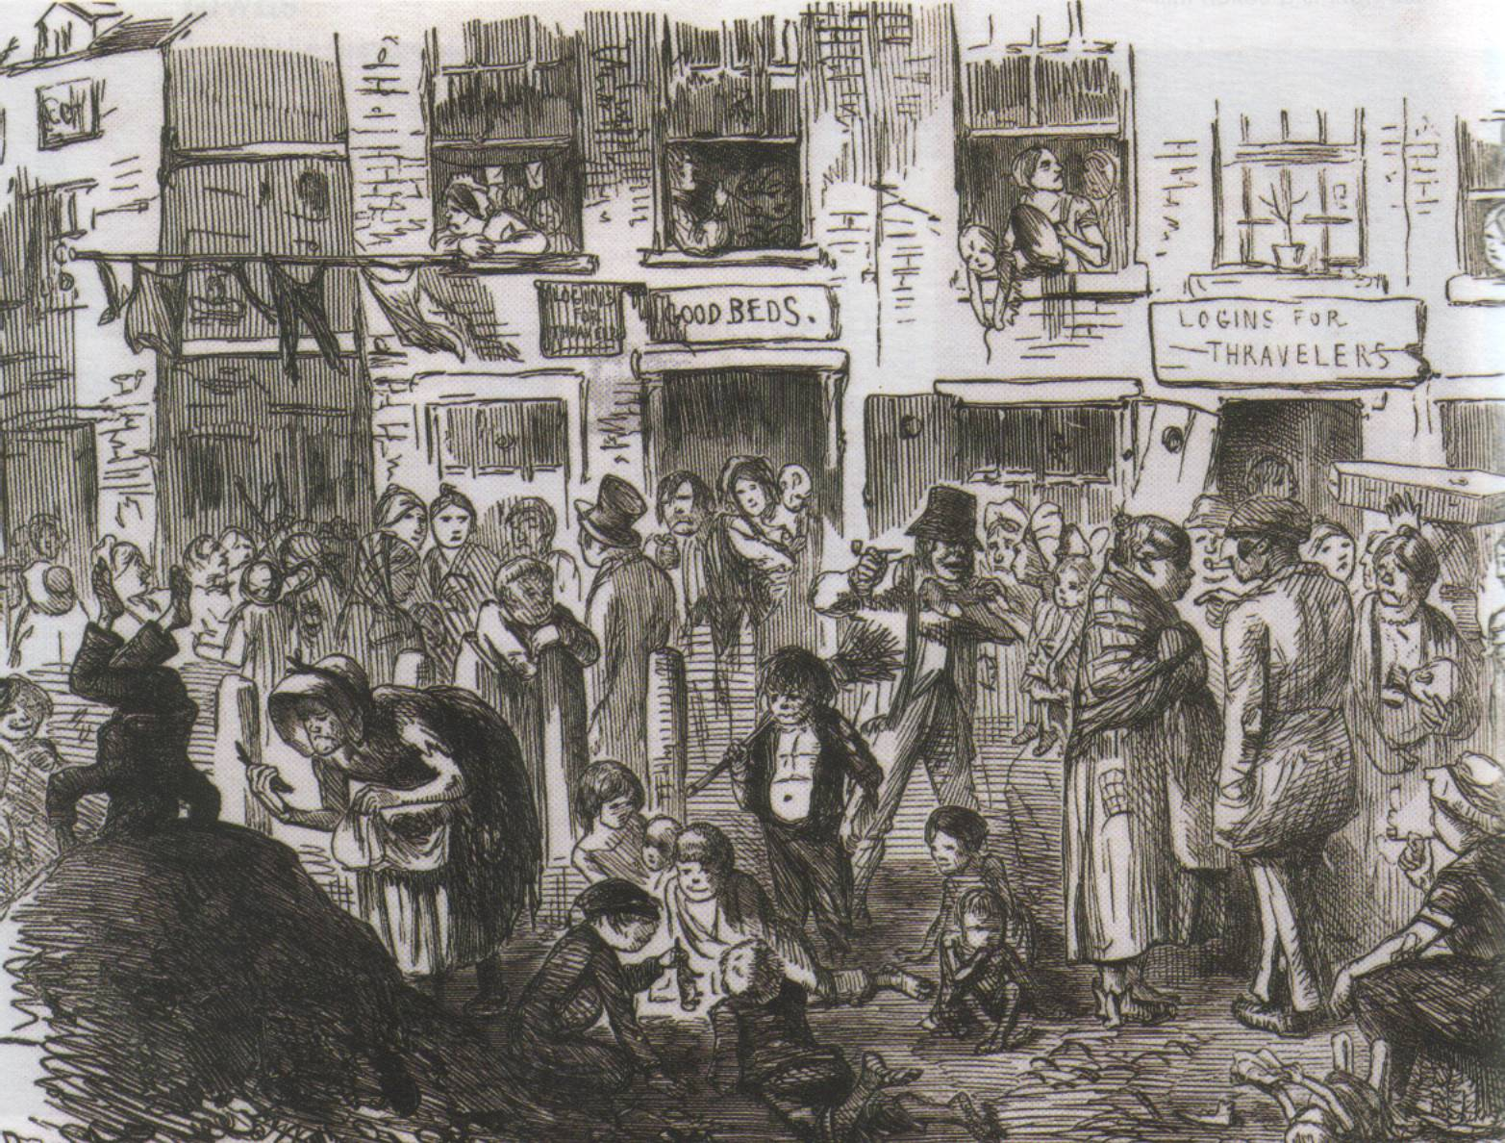
Poor ventilation – with houses built so close together it was difficult to get either fresh air or light into the room.
Damp – housing for the poor was often badly built. With earth floors, single brick walls and poor roofing materials, the houses were damp.

Hygiene – it was hard for people wash their clothes and themselves. Many people had body lice. Food storage was a problem too. Diseases like typhoid, typhus and diarrhoea flourished. Even royalty and the rich were not safe.
Sewage – this was a major problem as most houses were built without sewers or toilets. The houses usually shared a privy, which might be built over a stream or cesspit. Sewage leaked into the water supply. As the pits were not regularly emptied they often overflowed, particularly in wet weather. They stank and were also a breeding ground for disease.
Rubbish – In many towns there was no effective system for collecting rubbish. The piles of rotting rubbish in courtyards and streets were breeding grounds for disease.
Drinking water – most houses did not have piped water. People had to get water from cisterns, stand pipes, wells, streams or rivers. The waste of the town polluted all of these. This meant that water-carried diseases like cholera could easily spread.

