(Board notes or on Smart Board if available).

In 1838 Panic set in when Aboriginal people killed two settlers living in the area now known as Inverell (in Northern NSW). Twelve local stockmen (of which 11 were ex-convicts) were so angry about this they decided to take revenge. They rode to the nearest Aboriginal camp near Myall Creek and tied up 28 Aboriginal people including women and children; there victims were the relatives of Aboriginal men working with the stockmen. These Aboriginal people protested their innocence- they had been in friendly contact with local settlers. The stockmen ignored these pleas and beat their captives to death while they were all still tied together, then they burned the bodies. Seven of these attackers were later tried for murder and hanged.

Visit
http://www.newagemultimedia.com/isaacs/MyallCrk.html
for information on a present-day memorial to this event and more information about the massacre.

Check Your Understanding/Interpreting the Historical Clues:
1. In what year did the Myall Creek Massacre occur?
2. Why do you think this event is referred to as a massacre? (Hint- think about the meaning of the word ‘massacre’ = mass murder or slaughter).
3. What evidence is there that the police and legal system did not agree with what the stockmen did to the Aboriginal people at Myall Creek?

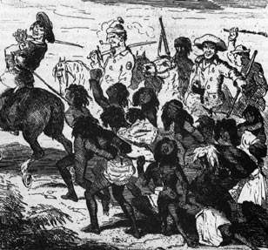
In 1838, panic set in when Aboriginal people killed two settlers living in the area now known as Inverell (in Northern NSW). Twelve local stockmen (of which 11 were ex-convicts) were so angry about this they decided to take revenge. They rode to the nearest Aboriginal camp near Myall Creek and tied up 28 Aboriginal people including women and children; their victims were the relatives of Aboriginal men working with the stockmen. These Aboriginal people protested their innocence- they had been in friendly contact with local settlers. The stockmen ignored these pleas and beat their captives to death while they were all still tied together, then they burned the bodies. Seven of these attackers were later tried for murder and hanged.

Visit
http://www.newagemultimedia.com/isaacs/MyallCrk.html
for information on a present-day memorial to this event and more information about the massacre.

Image from http://www.creativespirits.info/aboriginalculture/history/massacres-Myall-Creek-1838.html, accessed March 10, 2012

Check Your Understanding/Interpreting the Historical Clues:
1. In what year did the Myall Creek Massacre occur?
2. Why do you think this event is referred to as a massacre? (Hint- think about the meaning of the word ‘massacre’ = mass murder or slaughter).
3. What evidence is there that the police and legal system did not agree with what the stockmen did to the Aboriginal people at Myall Creek?

