Ninja vs Samurai Essay
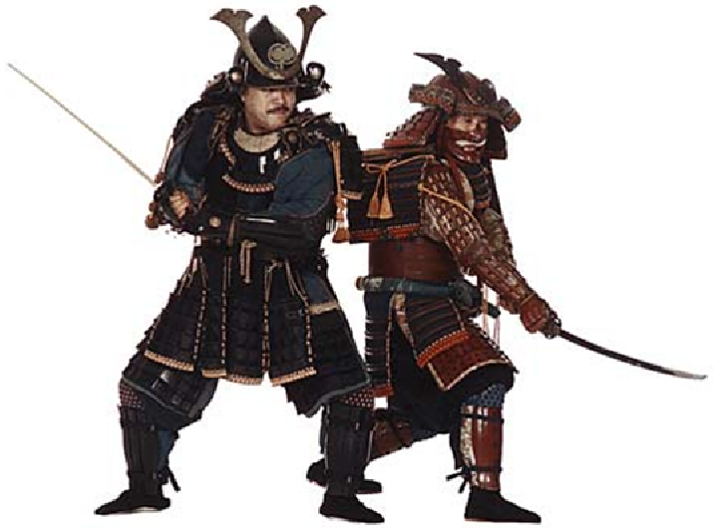
Task:
You are to write an essay which answers the following:
How are the Ninja and their beliefs and practices different from the samurai?
Use what you know about samurai’s and ninja’s to complete your essay. You can use the internet for further research.

How to structure a comparative essay:
Introduction
Explain what you are going to discuss in your essay. (Sometimes it can be easier to write the introduction last.)
Paragraph one (Choose what you are going to discuss, for example: beliefs, codes of conduct, ideas)
Explain how the topic is used/followed/understood by the samurai.
Then explain how the topic is used/followed/understood by the ninja.
Choosing different topics follow the same structure to complete the next four paragraphs.
Conclusion
Sum up what your essay was about. You could explain a few things that are very similar and a few things that are extremely different.

