The Samurai and Mushin

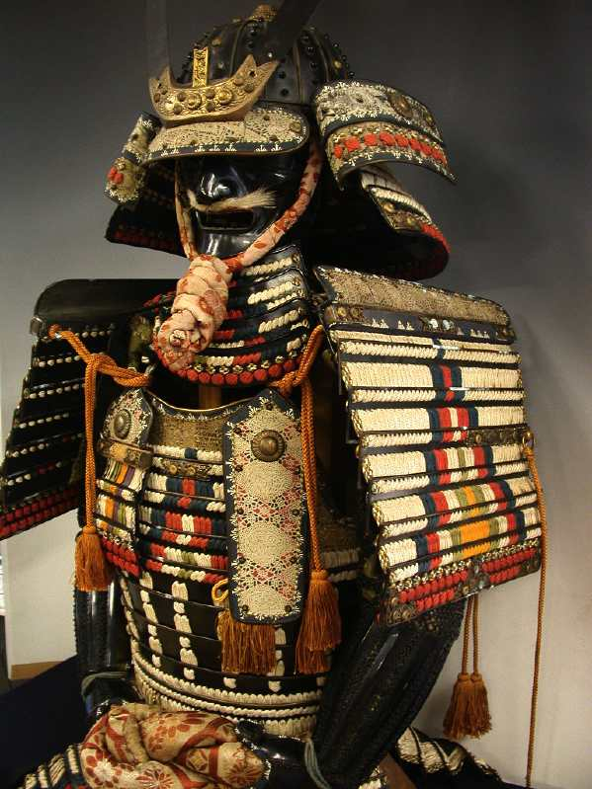
A samurai who attained mushin acted spontaneously and without thinking. In combat, he did not think about his fighting stance when to thrust his sword at an enemy’s vital organs or when to anticipate and parry a possible blow. Instead, he allowed his body to react spontaneous while his mind remained calm. AS a consequence, his actions were quicker and he became a better warrior.

Think about three different ways attaining mushin would benefit your life and describe them.

